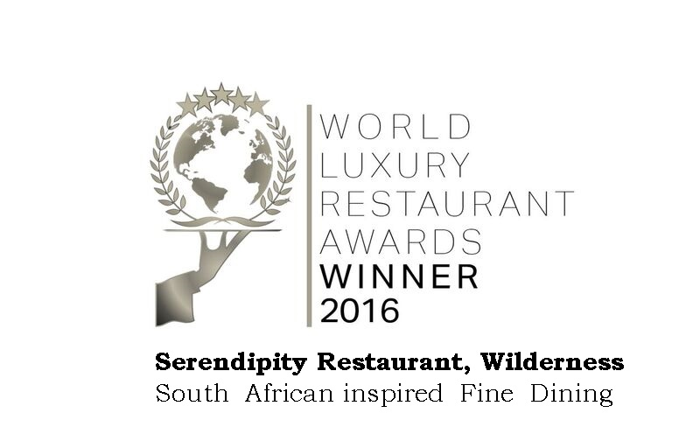From: Signe Da Silva <signe@luxuryrestaurantawards.com>   
Date: 20/06/2016 15:47 (GMT+02:00)   
To: info@serendipitywilderness.com   
Subject: OFFICIAL FINAL WINNER ANNOUNCEMENT AND PRESS RELEASE: 2016 World Luxury Restaurant Awards

Dear World Luxury Restaurant Awards Winner!

 After our highly successful World Luxury Restaurant Awards Gala Event in Switzerland, we are very pleased to finally announce the FULL WINNER results for the 2016 World Luxury Restaurant Awards.

**Restaurant Name:**                           **Serendipity**

**Category:**                                     South African Fine Dining Cuisine

**Country/Continent/Global:**        Global Winner  
  
We extend you a sincere thank you for your participation, and a very big congratulations, especially to all the restaurant staff involved in working hard to achieve this recognition.    
  
You will find a full list of winners by clicking on this link to our website: [**http://www.luxuryrestaurantawards.com/winners/2016-restaurant-awards**](http://www.luxuryrestaurantawards.com/winners/2016-restaurant-awards)

*We at Serendipity are so excited .....*

*A huge THANK YOU to all our passionate supporters.  Without your vote we would not have been at the top, recognized by International standards.*

*We will always share our passion with our diners and are looking forward to seeing you soon.*

*We are taking our annual winter break as from 24th June, and will open again on 23 July 2016.*

*Rudolf & Lizelle Stolze and the Serendipity crew*